Sri Lanka Institute of Information
Technology


2025-Y2-S1-MLB-WE1G2-08
Web Based Transportation System
SE2030 - Software Engineering
B.Sc. (Hons) in Information Technology
Group Members:
Student ID | Name
IT24101142 | Sandamuthu A.A.N
IT24510021 | Kulatunga W.M.H.P
IT24100839 | Janith Priyankara W.A
IT24101209 | Madusanka W. A. L. P
IT24100687 | Sansiri P.S.T
IT24100892 | Gamage G.A.G
Design Patterns We Used
- Singleton Pattern
- Strategy Pattern

1. Singleton Pattern
Where We used: database connection com/example/common/utils/DBUtil.java
Purpose: DBUtil provides a single shared database connection instance, preventing multiple connections and improving resource management.
The Singleton pattern ensures that only one instance of the DBUtil class exists throughout the application. This improves performance by reusing the same database connection object and avoids resource leaks.

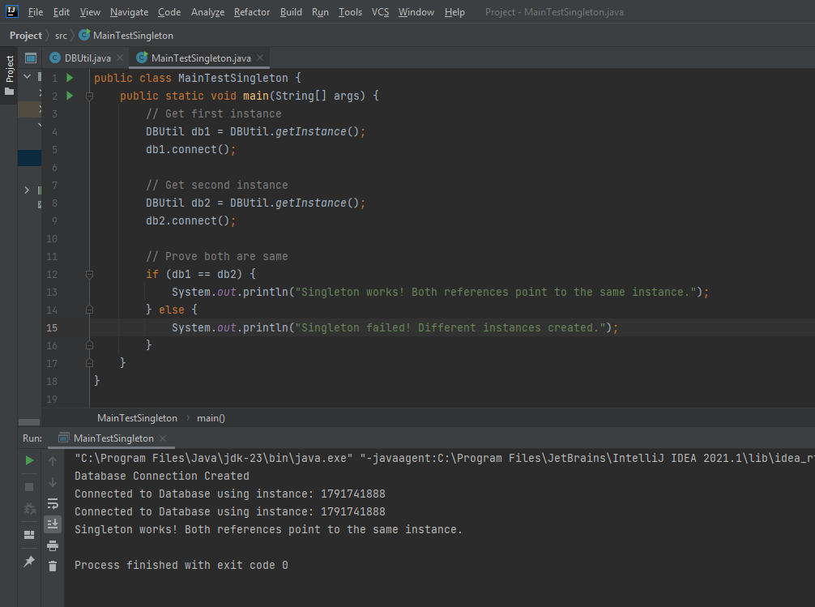

- Strategy Pattern
Where We used: Payment Module com.example.payment.service.PaymentService
Purpose: The Strategy Pattern is used to define a family of algorithms (different ways of processing a payment), encapsulate each one, and make them interchangeable at runtime without modifying the existing code.
The Strategy Pattern in your payment module improves flexibility and scalability by separating payment algorithms from the main business logic. It allows the system to handle multiple payment types without rewriting core functionality, a crucial feature for an evolving transportation system where users expect various payment options.

